Adding or inviting members to a team in an organization

Once you create a team, you can add existing organization members. If you add a user who isn't already a member of your organization, you can send them an invitation to join the organization and the team at the same time.

Each team has its own individually defined [access permissions for repositories](https://help.github.com/enterprise/11.10.340/user/articles/permission-levels-for-an-organization-repository).

Members of the Owners team can invite new members to the organization, and add or remove existing organization members from all teams. Only members of the Owners team can add or remove existing organization members from teams with read and write permissions.

Members of teams that give admin permissions can only add and remove other members and repositories for that team.

**Notes:**

* A team that's [synced to an LDAP group](https://help.github.com/enterprise/2.1/admin/guides/user-management/using-ldap#enabling-ldap-sync) is indicated with a special LDAP badge. The member list for an LDAP synced team can only be managed from the LDAP group it's mapped to. To add or invite a new member to a team synced to an LDAP group, contact your LDAP administrator.
* It's not possible to add an organization to another organization's team. Teams are limited to user accounts.

**Setting up a team**

1. On the left side of your profile page, under "Organizations", click the icon for your organization.
2. 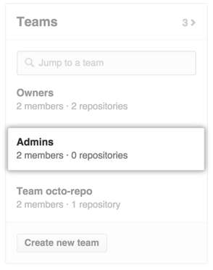On the right side of the organization profile page, under Teams, click the name of the team.
3. Type the username of the person you want to invite or add and press **Enter**.
   * 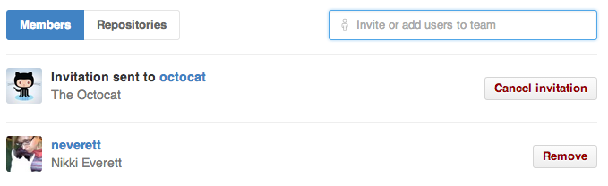If the user is not a member of your organization, they'll receive an email inviting them to the organization. They will need to accept the invitation before becoming a member of the organization.
   * 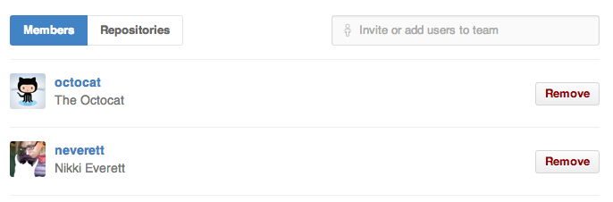If the user is already a member of your organization, they will immediately be added to the team.

**Note**: You can cancel an invitation any time before the user accepts by navigating to the team page and clicking **Cancel invitation** next to the user's invitation.

+++++++++++++++++++++++++++++++++++++++++++++++++++++++++++++++

Inviting collaborators to a personal repository

You can invite users to become collaborators with read or write access on your personal repository.

Repositories owned by an organization can grant more granular access. For more information, see "[What are the different access permissions?](https://help.github.com/articles/what-are-the-different-access-permissions)"

Note: GitHub limits the number of people who can be added to a repository within a 24-hour period. If you exceed this limit, either wait 24 hours or [create an organization](https://help.github.com/articles/what-s-the-difference-between-user-and-organization-accounts/).

1. Ask for the username of the person you're inviting as a collaborator. If they don't have a username yet, they can [sign up for GitHub](https://help.github.com/articles/signing-up-for-a-new-github-account).
2. On GitHub, navigate to the main page of the repository.
3. Under your repository name, click  **Settings**.
4. In the left sidebar, click **Collaborators**.
5. Under "Collaborators", start typing the collaborator's username.
6. 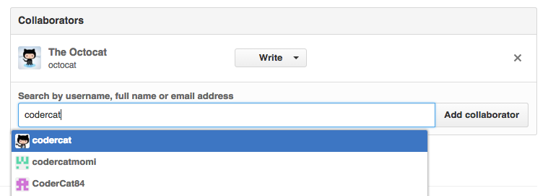Select the collaborator's username from the drop-down menu.
7. 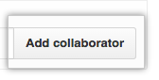Click **Add collaborator**.
8. The user will receive an email inviting them to the repository. Once they accept your invitation, they will have [collaborator access](https://help.github.com/articles/permission-levels-for-a-user-account-repository/#collaborator-access-on-a-repository-owned-by-a-user-account) to your repository.

+++++++++++++++++++++++++++++++++++++++++++++++++++++++++++++++++++++++++

Permission levels for a user account repository

A repository owned by a user account has two permission levels: the *repository owner* and *collaborators*.

**Tip:** If you require more granular read/write access to a repository owned by your user account, consider transferring the repository to [an organization](https://help.github.com/articles/what-s-the-difference-between-user-and-organization-accounts). For more information, see "[How to transfer a repository](https://help.github.com/articles/how-to-transfer-a-repository)."

**Owner access on a repository owned by a user account**

The repository owner has full control of the repository. In addition to all the permissions allowed by repository collaborators, the repository owner can:

* [Invite collaborators](https://help.github.com/articles/inviting-collaborators-to-a-personal-repository)
* Change the visibility of the repository (from [public to private](https://help.github.com/articles/making-a-public-repository-private), or from [private to public](https://help.github.com/articles/making-a-private-repository-public))
* Merge a pull request on a protected branch, even if there are no approved reviews
* [Delete the repository](https://help.github.com/articles/deleting-a-repository)

There is only **one owner** of a repository owned by a user account; this permission cannot be shared with another user account. To transfer ownership of a repository to another user, see "[How to transfer a repository](https://help.github.com/articles/how-to-transfer-a-repository)."

**Collaborator access on a repository owned by a user account**

Collaborators on a personal repository can:

* Push to (write), pull from (read), and fork (copy) the repository
* Apply labels and milestones
* Open, close, re-open, and assign issues
* Edit and delete comments on commits, pull requests, and issues
* Merge and close pull requests
* Send pull requests from forks of the repository
* Create and edit Wikis
* Create and edit Releases
* Remove themselves as collaborators on the repository
* Submit a review on a pull request that will affect its mergeability